World Games 2001 AKITA

Bulletin 3 - May 2001

1. General Information
Event Centre and Assembly Area
The center for the World Game races is located in Akita city, which is the capital of Akita prefecture in the north-east part of Honsyu Island on the Japan sea side. Akita city is about 600 km far from Tokyo (See Map 1).
The assembly area for the word games event is at Akita Prefectural University. Track and field of the university is served as the main site, and the gymnasium at the campus is used as a waiting room for the competitors.

Travel to and from the Event Centre
For people who will come by AIR PLANE
From Narita Airport to Haneda Airport
Airport limousine bus 90min \3,000 every 20 min.
From Haneda Airport to Akita Airport
Japan Airlines (JAL) or All Nippon Airways (ANA)
1hour \20,500 (Normal fare) 7 flights per day

For people who will come by TRAIN
From Narita Airport to Tokyo JR Station
1. JR Narita Express 55 min. \2,940 every 30 min.
2. JR Airport Narita 84 min. \1,280 every 1 hour
3. Keisei Skyliner 55 min. \1,920 every 40 min.
(from airport to Nippori) then JR lines from Nippori to Tokyo 20 min. \150
- Keisei Morningliner 70 min. \1,400
(from airport to Nippori) then JR lines from Nippori to Tokyo 20 min. \150
5. Airport limousine bus 80 min. \3,000 every 30 min.
From Tokyo JR Station to Akita JR Station
Komachi Super Express 4 hours \16,810 every 1 hour

For people who will come by BUS
From Narita Airport to Tokyo-Sinjuku JR Station
1. JR Narita Express 80 min. \3,110 every 30 min.
2. Airport limousine bus 85 min. \3,000 every 20 min.
From Tokyo-Sinjuku JR Station to Akita JR Station
Night bus 12 hours \9,450 1 service per day

Additional information is also on:
http://www.wg2001.or.jp/engimg/ea6000.htm
The Akita Organization Committee (of the World Games) will pick you up either at Akita JR station or Akita Airport.

Visas
We understand that visitors from following countries will require visas:
Lithuania, Russia, Slovakia, Ukraine
Please contact the Japanese embassy or consulate in your country for further information. All visitors are advised to confirm entry conditions to Japan (e.g. period of validity of passport) with their nearest Japanese embassy or consulate.

If documentation from Japan is required to support your visa application, this can be supplied by the Japan Orienteering Association. Please contact the following JOA office as soon as possible:
3-28-2 Shiba, Minato-ku, Tokyo 105 Japan
Tel +81-(0)3-5476-5657
Fax +81-(0)3-5476-5658
Please allow ten days for issuing this documentation.

2. Event Programme
Programme Details
World Games Events
Wednesday 15th August
During the day Arrival
18:00 – 18:30 Team leader information meeting
18:30 – 20:00 Dinner

Thursday 16th August
During the day Jet lag day
07:30 – 09:00 Breakfast
10:00 – 11:30 Training opportunity
11:30 – 12:30 Lunch
15:00 – 17:00 Opening ceremony of the World Games
19:00 – 20:00 Dinner

Friday 17th August
07:00 – 09:00 Breakfast
10:00 – 12:00 Model event
12:00 – 12:30 Start draw (not open for public)
12:30 – 14:00 Lunch
17:00 – 18:00 Team leader meeting
18:00 – 20:00 Dinner

Saturday 18th August
06:00 – 08:00 Breakfast
09:00 – 09:20 Opening race ceremony
10:00 Start Men Individual Race
10:50 Start Women Individual Race
12:15 – 12:35 Prize giving ceremony at Akita Prefectural University
11:30 – 13:30 Lunch at Akita Prefectural University
17:00 – 18:00 Team leader meeting
18:00 – 20:00 Dinner

Sunday 19th August
06:00 – 08:00 Breakfast
09:30 Start Mix Relay
11:45 – 12:00 Flower ceremony at Akita Prefectural University
12:00 – 13:30 Lunch at Akita Prefectural University
15:45 – 16:00 Prize giving ceremony at the World Games Plaza in downtown Akita
19:00 – 20:30 World Games Party

Monday 20th August
07:30 – 09:00 Breakfast
Departure of teams

Spectator Races
Free foot orienteering events are held in the terrain used for the World Games Model Event on Saturday 18th August. Spectator races are held on Sunday 19th August. For further information, please contact Mr. Shin MURAKOSHI.
Trail orienteering is held after the World game races on Sunday 19th August. Any individual (not only disabled) is welcome to attempt this course.

Ceremony
All teams should take part in the official opening ceremony of the World games on Thursday 16th August.
Opening race ceremony is held before races on Saturday 18th August. Competitors do not need to attempt to this ceremony.
All teams are invited to World Games Party on Sunday 19th August.

3. Accommodation and Transport during the World Games
Accommodation and Catering
Accommodation with meals is provided for all the competitors by Akita Organizing Committee (AOC) without charge. All the rooms are single without toilet and bath. Team officials can stay at the same accommodation, but will be charged (ca. 7,500 yen per night with three meals). The accommodation cost for team officials need to be paid in advance to the AOC through IOF secretariat before booking will be made. This is stated in the information received from the AOC through IOF secretariat.
If any member of your team has any special requirements, such as vegetarian, please contact Mr. Shin MURAKOSHI in advance.

Transport during the Event
Bus transport will be provided for events and official ceremony. On the way back from the events, some of the buses will stop at a supermarket if required. The transport is provided by AOC for free. If required, transport will be provided for free time activities, e.g., sight seeing, at relevant cost. Please contact IOF secretariat for transport for free time activities.

4. Technical Information
Terrain Description
The terrain for both races is a sand dune area stretching along the coastline north of Akita. The area is rather narrow from 500 – 1000 m wide and is mostly covered by pine forest and has rather complex contour detail. Highest point is about 60 m and lowest about 5 m above sea level. There are hardly any wet areas or rock features, but a detailed system of tracks and smaller roads. The runnability varies from very clean pine forest to undergrowth of mostly light green character.
You may run across some irritant plants that could make you get a rash. There are a lot of caterpillars in the terrain.
Illegal garbage had been thrown in the terrain, but will be cleaned up by local student volunteers. The competitors might encounter it which is overlooked, but it is not dangerous if the competitors does not cross over it.

Maps
Scales: 1:10,000
Contour interval: 2.5 m
Enclosed with this bulletin is a previous O-map of Akita that was used in 1993 (Map 2).

Course Information
Individual race
 | Length (km) | Winning time (min) | Controls
Men | 6.7 | 32 | 22
Women | 5.5 | 32 | 18

Mix relay
 | Length (km) | Winning time (min) | Controls
Men | 5.25 – 5.35 | 25 | 18
Women | 4.47 – 4.54 | 25 | 15

A sample map of the northern part of the forest is enclosed (Map3).

Electronic punching
The Emit electronic punching system will be used in all races of the World Games.

Clothing Restrictions
Full-length metal spikes are prohibited. Stud spikes may be worn. There is no clothing restriction but full body coverage is strongly recommended.
It is required to inform the AOC in advance about any logo/symbol mark of sponsors on O-suits used for model event and races. Description / picture of sponsor logos shall be submitted together with preliminary entry form. A form to be used for this purpose has already be circulated to the invited federations by the end of October 2000. Please contact Mr. Shin MURAKOSHI for any more details.

Embargoed Areas
The location of the embargoed areas is shown on the map 4.

Training Opportunities
An official training will be arranged on 16th August 2001 using controls for the model event.
If any teams require training opportunities before 15th August 2001, this must take place outside Akita. Different types of terrain can be offered. In this case, all the cost for the training will be charged.
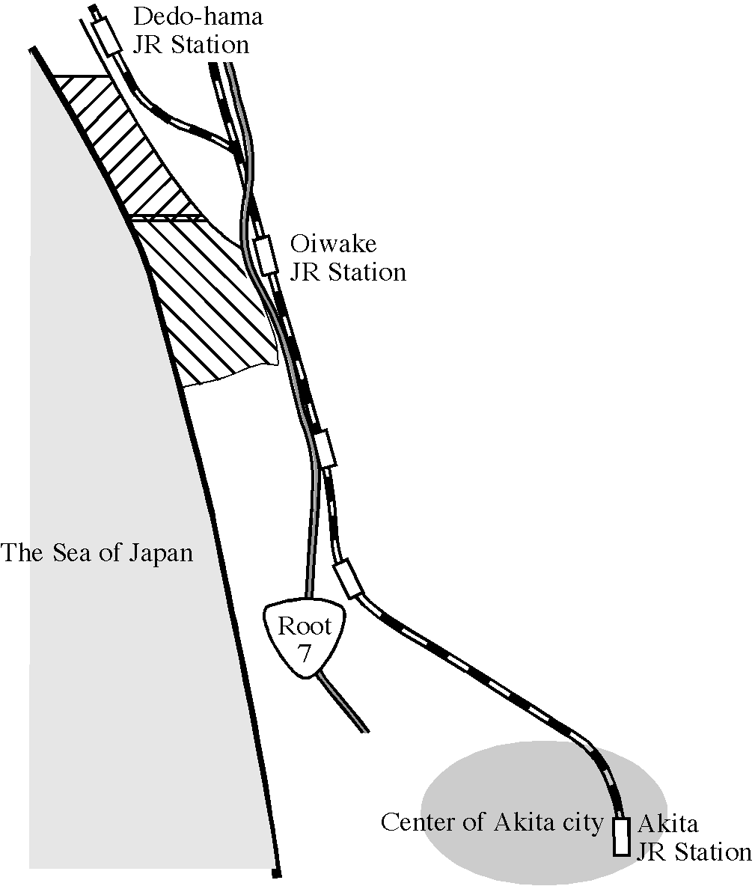
Map 4 Embargoed areas
Dedo-hama
Start Draw
Start draw according to Competition rule 9.13 but with only 2 start groups. Start numbers 1 and 2 form pair 1, start numbers 3 and 4 form pair 2 etc. Runners from the same Federation cannot start in the same pair. Principles from Competition rule 12.10 will apply.
Nakano-hama
&
Oiwake
Start interval is 2 minutes. There are 2 loops in the course, i. e., A and B, one competitor runs AB, the other runs BA. After this, the controls will be common.

Climate Conditions
The average temperature in Akita city in August is about 24 degree C, with the highest at about 29 degree C and lowest 21 degree C. It is mostly clear and warm.

5. Team Information and Entry
The number of competitors in orienteering at the world games is limited to 80 (40 men and 40 women). Following is the summery of received team entries:

Nation | Men | Women | Total
Australia | 3 | 2 | 5
Czech Republic | 2 | 2 | 4
Denmark | 3 | 2 | 5
Estonia | 2 | 2 | 4
Finland | 4 | 4 | 8
France | 2 | 2 | 4
Germany | 2 | 2 | 4
Great Britain | 3 | 3 | 6
Hungary | - | 1 | 1
Japan | 2 | 2 | 4
Lithuania | 2 | 2 | 4
Norway | 3 | 3 | 6
Poland | 2 | 2 | 4
Russia | 2 | 2 | 4
Slovakia | 1 | - | 1
Spain | - | 1 | 1
Sweden | 3 | 3 | 6
Switzerland | 3 | 4 | 7
Ukraine | 1 | 1 | 2

A medical doctor and a physiotherapist will be supplied by IOF and will be available for all competitors.
Final entry (name of competitors and officials) must reach the IOF Secretariat no later than 21st of May 12 GMT 2001. Entry fee for all the competitors is free. A fee for team officials will be charged.

6. Organization
Key personnel are:
Event director Shin MURAKOSHI
Fax/ tel.: +81-543-34-9754
e-mail: shin@orienteering.com
Course planners Yusuke ONODA (Individual race)
Yasuaki ISHII (Relay)
IOF Controller Oivind HOLT (Norway)
General secretary Michiko SUGAWARA

7. Additional Information
For public relation, there will be an introduction program of orienteering for local primary school children on Saturday 18th August. Runners who will not run on Sunday are kindly requested to help instructing orienteering to them. Further details will be informed in the program.

For further information regarding the World Games and media service, please contact the following address:
IOF Secretariat
Radiokatu 20, FI-00093 SLU, FINLAND
tel. +358-9-3481-3112 / fax +358-9-3481-3113
e-mail: iof@orienteering.org

